Requirement already satisfied: xgboost in /usr/local/lib/python3.12/dist-packages (3.2.0) Requirement already satisfied: lightgbm in /usr/local/lib/python3.12/dist-packages
(4.6.0)
Collecting catboost
Downloading catboost-1.2.10-cp312-cp312-manylinux2014_x86_64.whl.metadata (1.2 kB) Requirement already satisfied: numpy in /usr/local/lib/python3.12/dist-packages (from xgboost) (2.0.2)
Requirement already satisfied: nvidia-nccl-cu12 in /usr/local/lib/python3.12/dist- packages (from xgboost) (2.30.7)
Requirement already satisfied: scipy in /usr/local/lib/python3.12/dist-packages (from xgboost) (1.16.3)
Requirement already satisfied: graphviz in /usr/local/lib/python3.12/dist-packages (from catboost) (0.21)
Requirement already satisfied: matplotlib in /usr/local/lib/python3.12/dist-packages (from catboost) (3.10.0)
Requirement already satisfied: pandas<4.0,>=0.24 in /usr/local/lib/python3.12/dist- packages (from catboost) (2.2.2)
Requirement already satisfied: plotly in /usr/local/lib/python3.12/dist-packages (from catboost) (5.24.1)
Requirement already satisfied: six in /usr/local/lib/python3.12/dist-packages (from catboost) (1.17.0)
Requirement already satisfied: python-dateutil>=2.8.2 in /usr/local/lib/python3.12/dist- packages (from pandas<4.0,>=0.24->catboost) (2.9.0.post0)
Requirement already satisfied: pytz>=2020.1 in /usr/local/lib/python3.12/dist-packages (from pandas<4.0,>=0.24->catboost) (2025.2)
Requirement already satisfied: tzdata>=2022.7 in /usr/local/lib/python3.12/dist-packages (from pandas<4.0,>=0.24->catboost) (2026.2)
Requirement already satisfied: contourpy>=1.0.1 in /usr/local/lib/python3.12/dist- packages (from matplotlib->catboost) (1.3.3)
Requirement already satisfied: cycler>=0.10 in /usr/local/lib/python3.12/dist-packages (from matplotlib->catboost) (0.12.1)
Requirement already satisfied: fonttools>=4.22.0 in /usr/local/lib/python3.12/dist- packages (from matplotlib->catboost) (4.63.0)
Requirement already satisfied: kiwisolver>=1.3.1 in /usr/local/lib/python3.12/dist- packages (from matplotlib->catboost) (1.5.0)
Requirement already satisfied: packaging>=20.0 in /usr/local/lib/python3.12/dist-packages (from matplotlib->catboost) (26.2)
Requirement already satisfied: pillow>=8 in /usr/local/lib/python3.12/dist-packages (from matplotlib->catboost) (11.3.0)
Requirement already satisfied: pyparsing>=2.3.1 in /usr/local/lib/python3.12/dist- packages (from matplotlib->catboost) (3.3.2)
Requirement already satisfied: tenacity>=6.2.0 in /usr/local/lib/python3.12/dist-packages (from plotly->catboost) (9.1.4)
Downloading catboost-1.2.10-cp312-cp312-manylinux2014_x86_64.whl (97.1 MB)
━━━━━━━━━━━━━━━━━━━━━━━━━━━━━━━━━━━━━━━━ 97.1/97.1 MB 9.4 MB/s eta 0:00:00 Installing collected packages: catboost
Successfully installed catboost-1.2.10 Shape: (1460, 81)
Id MSSubClass MSZoning LotFrontage LotArea Street Alley LotShape \ 0 1 60 RL 65.0 8450 Pave NaN Reg
1 2 20 RL 80.0 9600 Pave NaN Reg 2 3 60 RL 68.0 11250 Pave NaN IR1 3 4 70 RL 60.0 9550 Pave NaN IR1 4 5 60 RL 84.0 14260 Pave NaN IR1
LandContour Utilities ... PoolArea PoolQC Fence MiscFeature MiscVal MoSold \ 0 Lvl AllPub ... 0 NaN NaN NaN 0 2

1 Lvl AllPub ... 0 NaN NaN NaN 0 5 2 Lvl AllPub ... 0 NaN NaN NaN 0 9 3 Lvl AllPub ... 0 NaN NaN NaN 0 2 4 Lvl AllPub ... 0 NaN NaN NaN 0 12
YrSold SaleType SaleCondition SalePrice 0 2008 WD Normal 208500 1 2007 WD Normal 181500 2 2008 WD Normal 223500 3 2006 WD Abnorml 140000 4 2008 WD Normal 250000
[5 rows x 81 columns]
Shape after outlier removal: (1429, 81) Number of numeric columns: 41
Number of categorical columns: 45
Train shape: (1143, 86) Valid shape: (286, 86)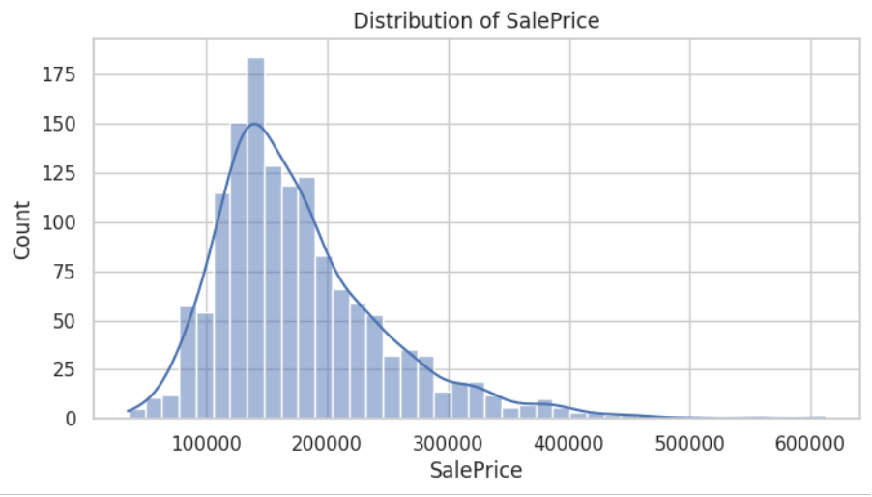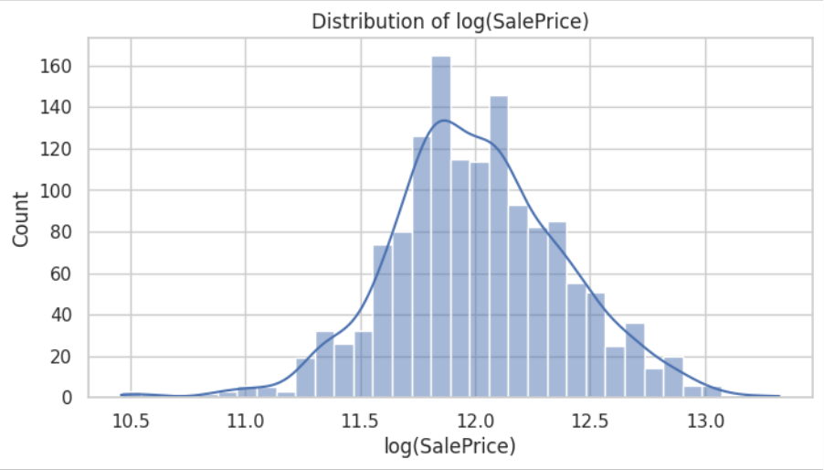

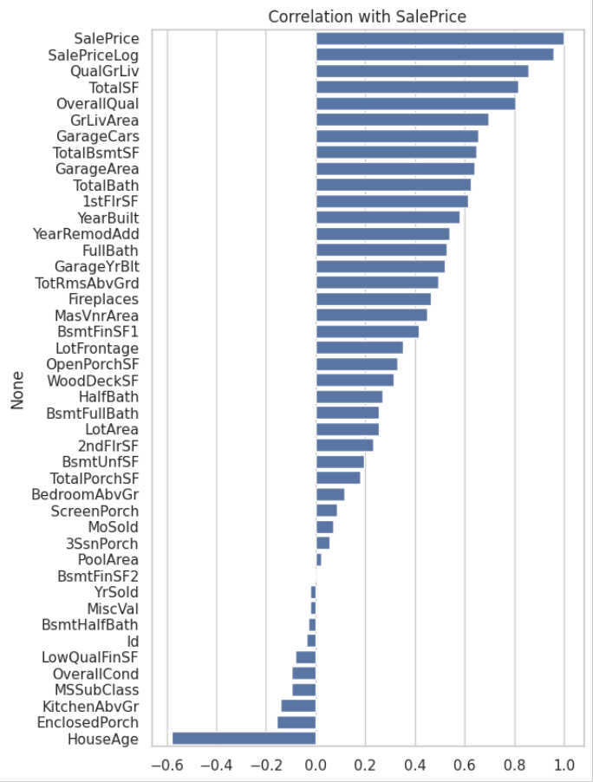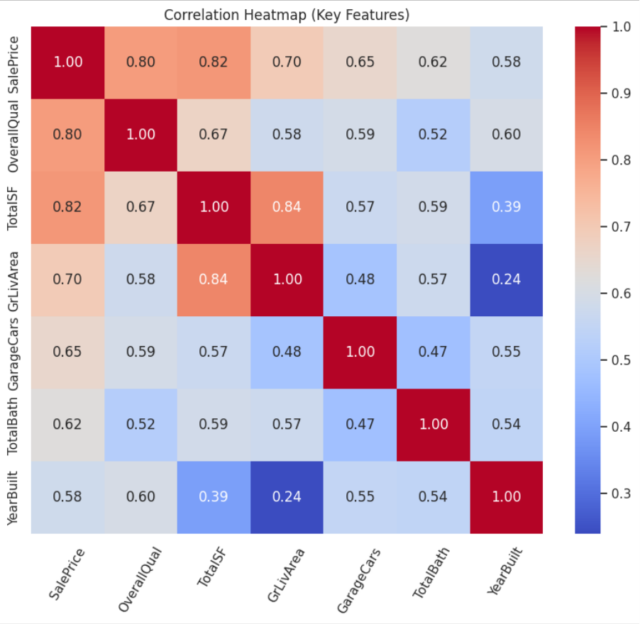

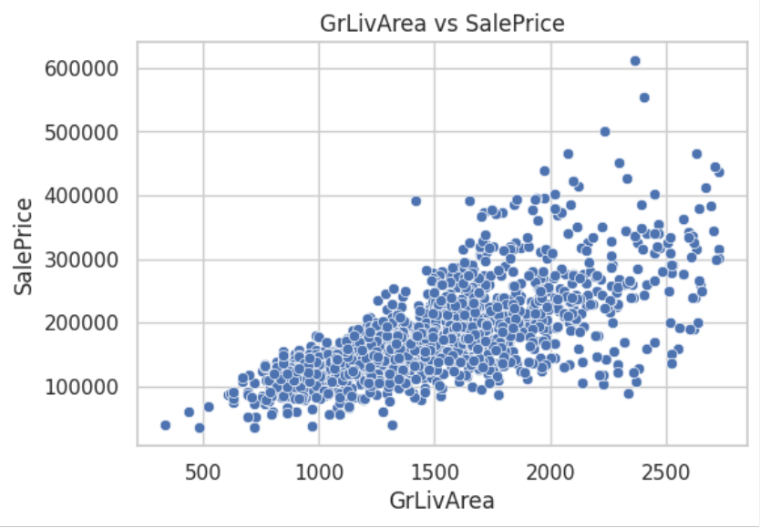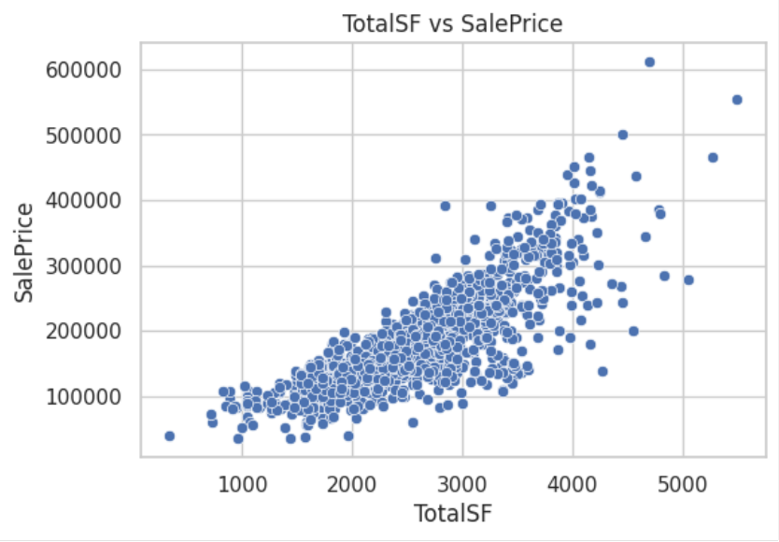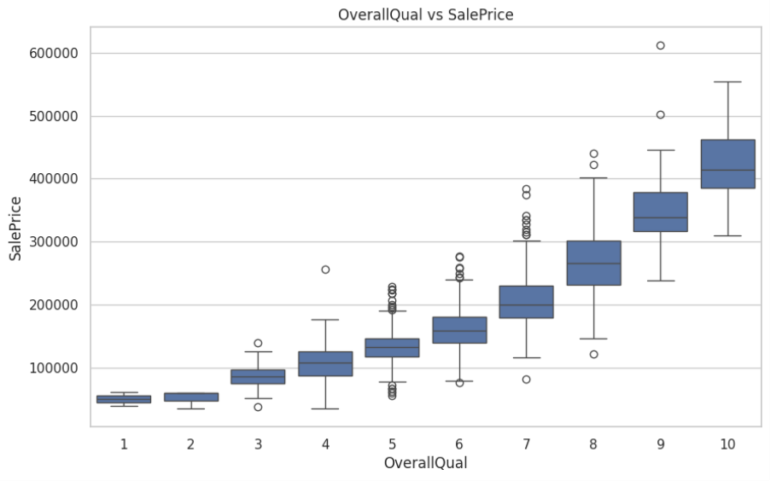

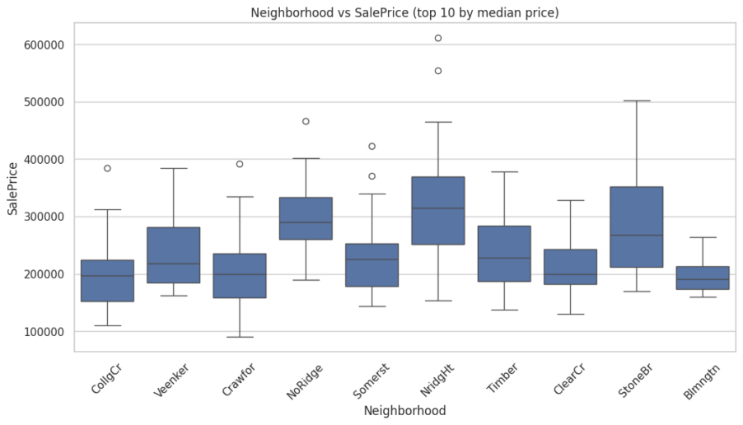

XGBoost
RMSE (log): 0.11645414968686062 MAE (log): 0.07871317385141106 R^2 (log): 0.9040946336667673 RMSE (price): 19005.570180259892 MAE (price): 12996.756173513986 R^2 (price): 0.9240184555616573
[LightGBM] [Info] Auto-choosing row-wise multi-threading, the overhead of testing was 0.002518 seconds.
You can set `force_row_wise=true` to remove the overhead.
And if memory is not enough, you can set `force_col_wise=true`. [LightGBM] [Info] Total Bins 3953
[LightGBM] [Info] Number of data points in the train set: 1143, number of used features:
205
[LightGBM] [Info] Start training from score 12.007860

/usr/local/lib/python3.12/dist-packages/sklearn/utils/validation.py:2739: UserWarning: X does not have valid feature names, but LGBMRegressor was fitted with feature names
warnings.warn(

LightGBM
RMSE (log): 0.12709504879620437 MAE (log): 0.08453799229235723 R^2 (log): 0.8857673542380547 RMSE (price): 21625.08163895048 MAE (price): 14410.49878759878 R^2 (price): 0.9016301924299672
CatBoost
RMSE (log): 0.10897176447584231 MAE (log): 0.07201744848030077 R^2 (log): 0.9160228875392215 RMSE (price): 18121.839554940798 MAE (price): 12236.736997346328 R^2 (price): 0.9309202316716818
Model performance summary:
Model RMSE_log MAE_log R2_log RMSE_price MAE_price \ 0 XGBoost 0.116454 0.078713 0.904095 19005.570180 12996.756174

1 LightGBM 0.127095 0.084538 0.885767 21625.081639 14410.498788 2 CatBoost 0.108972 0.072017 0.916023 18121.839555 12236.736997
R2_price 0 0.924018 1 0.901630 2 0.930920

 | Model | RMSE_log | MAE_log | R2_log | RMSE_price | MAE_price | R2_price
0 | XGBoost | 0.116454 | 0.078713 | 0.904095 | 19005.570180 | 12996.756174 | 0.924018
1 | LightGBM | 0.127095 | 0.084538 | 0.885767 | 21625.081639 | 14410.498788 | 0.901630
2 | CatBoost | 0.108972 | 0.072017 | 0.916023 | 18121.839555 | 12236.736997 | 0.930920

